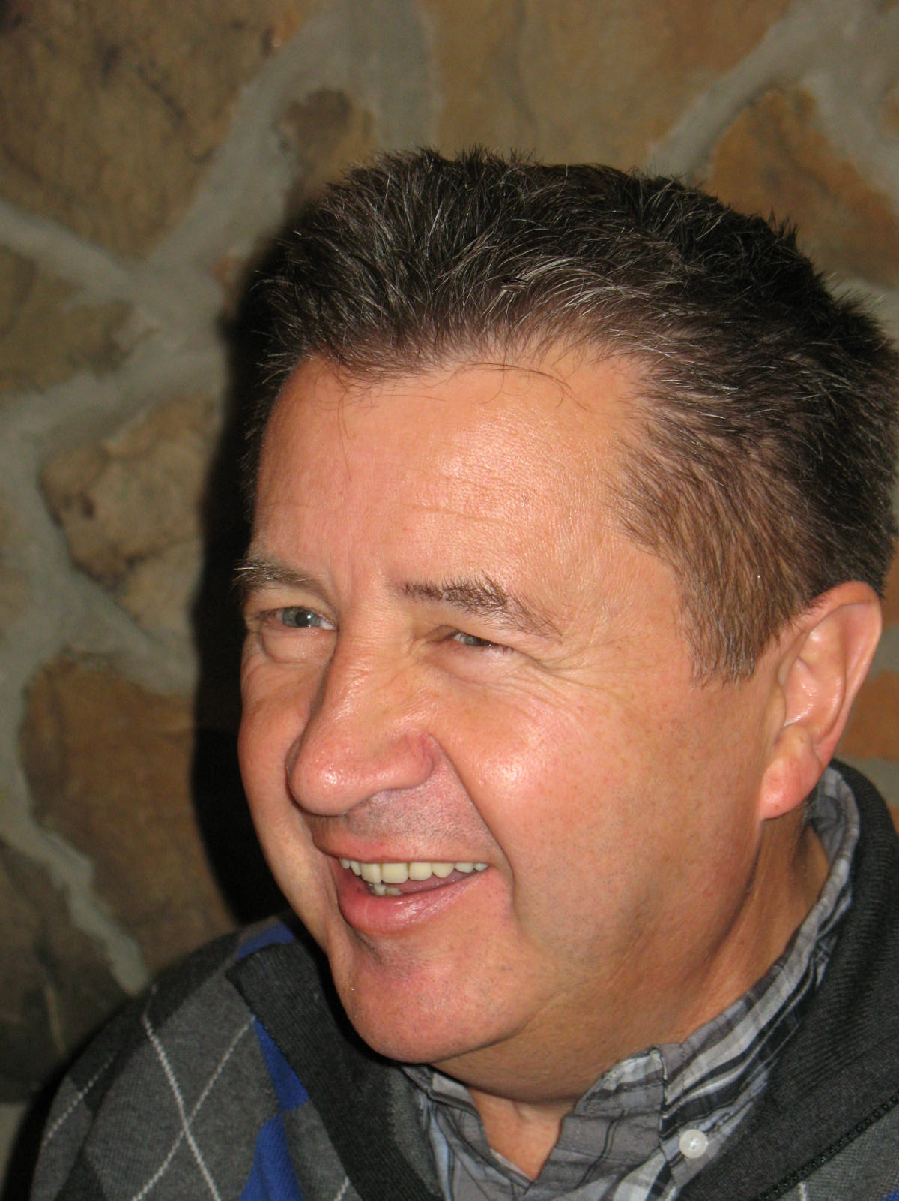
A Celebration of Life for
Ron Keras
September 8, 1948 – February 20, 2016
Please join us in celebrating
"a life well lived and a man well loved."
Prayer Service:
Thursday, February 25, 2016 @ 7:00 pm
Saint Joseph the Worker Parish Church
4451 Williams Road, Richmond, BC
Funeral:
Friday, February 26, 2016 @ 11:00 am
Saint Joseph the Worker Parish Church
4451 Williams Road, Richmond, BC
Reception to follow at the Parish School Hall
As this is a CELEBRATION OF LIFE, black attire is not mandatory.
In lieu of flowers, please make a donation to the ALS Society:
https://secure.e2rm.com/registrant/donate.aspx?eventid=56456&langpref=en-CA&Referrer=http%3A%2F%2Fals.ca%2Fdonate%2Fmemorialtribute%2Fone-time-donation

